# [PUBLICATION TITLE]

[Mandatory. The title must include the name of the assessed stock “[stock area] [species] (*formal taxonomic treatments*), ‘Stock Assessment’ or ‘Update’ in [assessment year]”. Assessment year is the last year of the data being used in the assessment.]

|  |
| --- |
| Context:  [Mandatory. Less than 150 words]  [This section will be posted in HTML format on the CSAS website followed by the link to the full PDF version of the publication. Context text- Style “Context - text”: Arial, size 10, italics, left aligned, paragraph spacing 3pt (0.04 in, 0.10 cm) before and after.]  Stock and Assessment Overview Document:[provide hyperlink] [stock area][species]  This Science Advisory Report is from the [meeting date and title (e.g., January 25, 2011 Assessment of Quebec inshore waters softshell clam)]. Additional publications from this meeting will be posted on the [*Fisheries and Oceans Canada (DFO) Science Advisory Schedule*](http://www.isdm-gdsi.gc.ca/csas-sccs/applications/events-evenements/index-eng.asp) as they become available.  [See guidance for examples of additional information to provide in the Context section.] |

## SCIENCE ADVICE

[Mandatory. Maximum length 500 words. Include summary bullets of the following factors affecting the stock that are **relevant for decision-making**. Please refer to the Guidance Document for standardized language and examples, and what to avoid in this section.]

**Status**

* [Mandatory bullet(s)]

**Trends**

* [Mandatory bullet(s)]

**Environmental and Climate Change Considerations**

* [Mandatory bullet(s)]

**Stock Advice**

* [Mandatory bullet(s)]

**Other Management Questions** [if applicable, otherwise do not include]

* [Other bullets if applicable]

## BASIS FOR ASSESSMENT

### Assessment Details

[Mandatory]

#### Year Assessment Approach was Approved

[Mandatory; year and reference]

#### Assessment Type

[Mandatory; select one of the following: Full Assessment, Interim Year Update, or Harvest Decision Rule (HDR) Update. See the Guidance Document for definitions.]

#### Most Recent Assessment Date

1. Last Full Assessment: [date and reference]
2. Last Interim Year Update: [date and reference]

#### Assessment Approach

1. Broad category: [Select one of the following: Data-poor (e.g., catch-MSY, very limited data, etc.), index-based (trends in empirical indices only), single stock assessment model, model ensemble, MSE (full or MSE-lite), Wild Salmon Policy Integrated Assessment, multiple approaches, other (specify)]
2. Specific category: [Select one or as many as apply: No data, Index-based (fishery-dependent indices only), Index-based (including fishery-dependent and fishery-independent indices), Delay difference, Biomass dynamics, Virtual population analysis, Statistical catch-at-length, Statistical catch-at-age, State-Space, Sequential Population Analysis, Surplus Production, Stock-Recruitment Relationship, Potential Biological Removal, Other (please explain)]

[Optional short summary of stock assessment methodology. Maximum length 100 words.]

### Stock Structure Assumption

[Mandatory. Maximum length 150 words.]

### Reference Points

[Mandatory. A table may be used in lieu of bullets for this section. Refer to the Guidance Document for further instructions.]

* Limit Reference Point (LRP):
* Upper Stock Reference (USR):
* Removal Reference (RR):
* Target (TRP):

#### Other Stock Reference Points

[If applicable (otherwise, do not include). A table may be used in lieu of bullets for this section.]

#### Hatchery Reference Points

[If applicable (otherwise, do not include). A table may be used in lieu of bullets for this section.]

#### Habitat or Ecosystem Reference Points

[If applicable (otherwise, do not include). A table may be used in lieu of bullets for this section.]

### Harvest Decision Rule

[Optional (otherwise, do not include). Maximum length 100 words.]

### Enhancement Plan

[Optional (otherwise, do not include). Maximum length 100 words.]

### Habitat Restoration Plan

[Optional (otherwise, do not include). Maximum length 100 words.]

### Data

[Mandatory. Maximum length 300 words.]

Data changes: [Optional (otherwise, do not include).

## ASSESSMENT

[Mandatory panel of images comes first – example shown. Refer to the Guidance Document for options and further instructions.]

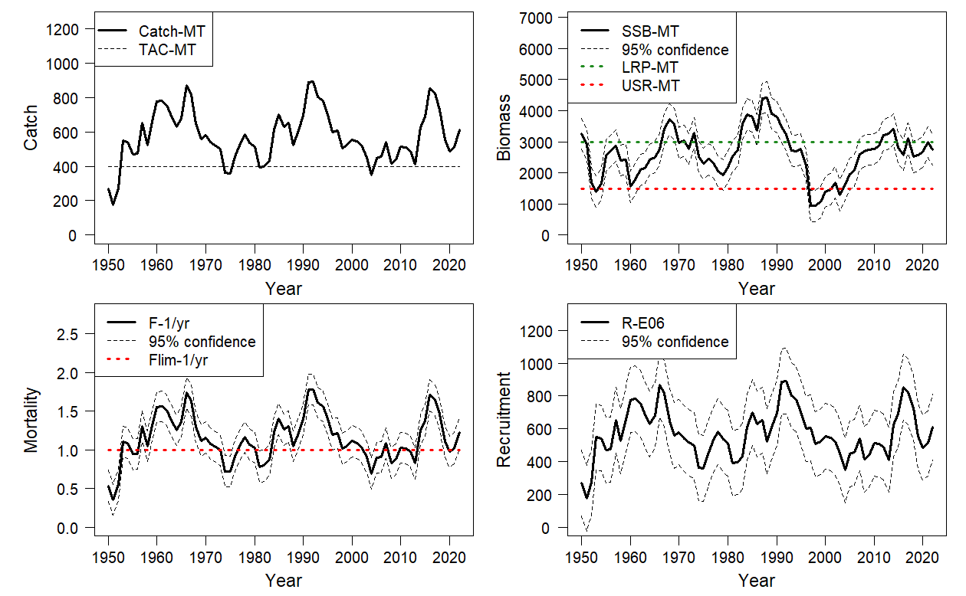

Figure 1. (A) Catch vs Total Allowable Catch, (B) Spawning Stock Biomass (SSB) in relation to the Limit Reference Point (LRP; X) and (proposed) Upper Stock Reference (USR; X, (C) Fishing Mortality (F; X) on the left in relation to the Removal Reference (RR) and Natural Mortality (M) on the right, (D) Recruitment (numbers).

[Optional. Add an additional optional panel of 4 indicators if relevant to developing advice.]

[Optional. If the FSAR or FSRR is being used to provide advice for more than one stock, the mandatory panel can be repeated for each stock.]

### Historical and Recent Stock Trajectory and Trends

[Mandatory. Maximum text length one page. Must be first section in Assessment section.]

[Report trends in relevant indicator(s), one per paragraph, in the following format:]

#### **[Indicator 1]** [specify name, e.g., Abundance]:

[Provide values and trends for the stock (as applicable).]

#### Unknown

[Optional. Indicate what indicators are not available for the stock (as applicable); otherwise, do not include.]

### **History of [Management; Landings/Harvest/Effort, TAC & Catch Advice]**

[Mandatory. Title can vary. Maximum text length one page.]

#### **History of Hatchery and Supplementation**

[If applicable (otherwise, do not include).]

#### **History of Freshwater Habitat Impacts**

[If applicable (otherwise, do not include).]

### Projections [optional titles: Simulations, Future Scenarios]

[Mandatory. Title can vary. Tables or figures can be used as necessary to support decision-making.]

### **Environmental and Climate Change Considerations**

[Mandatory. Maximum 300 words. May be moved earlier in the Assessment section.]

### Harvest Decision Rule Outputs

[If applicable (otherwise, do not include).]

### **Evaluation of Exceptional Circumstances/Assessment Triggers**

[If applicable (otherwise, do not include).]

## BYCATCH

[Optional (otherwise, do not include).]

## **PROCEDURE FOR INTERIM YEAR UPDATES**

[Optional (otherwise, do not include).]

## Other Management Questions

[Optional (otherwise, do not include).]

## SOURCES OF UNCERTAINTY

[Mandatory. Maximum length 500 words.]

### Research Recommendations

[Optional (otherwise, do not include).]

## LIST OF MEETING PARTICIPANTS

[Mandatory. The list is to include the name of each participant and their affiliation.]

## SOURCES OF INFORMATION

[Mandatory.]

[The following paragraph is optional for the Context and **MANDATORY** for the Sources of Information.]

[References should only be included to understand the advice, and should not be included to give credit to the work as they are done in the Research Document.]

This Science Advisory Report is from the [meeting date and title (The meeting process, date and title **MUST BE EXACTLY** as they appear for the meeting on the Science Advisory Schedule]. Additional publications from this meeting will be posted on the [Fisheries and Oceans Canada (DFO) Science Advisory Schedule](http://www.isdm-gdsi.gc.ca/csas-sccs/applications/events-evenements/index-eng.asp) as they become available.

[References must be formatted according to the *[Guide for the Production of Fisheries and Oceans Canada Reports](https://waves-vagues.dfo-mpo.gc.ca/Library/333125.pdf)*[.]](https://waves-vagues.dfo-mpo.gc.ca/Library/333125.pdf)

[References listed in the References Cited section should be publicly available when the report is posted on the website. The only exception is for books or articles that have been accepted for publication (page proof stage or where there is an acceptance letter). These can be listed followed by the notation “in press”. All others should be included in the text as unpublished data or working papers.]

## THIS REPORT IS AVAILABLE FROM THE:

Center for Science Advice (CSA) (Shift+Enter)  
Name of Region (Shift+Enter)  
Fisheries and Oceans Canada (Shift+Enter)  
Complete mailing address of CSA Office

Telephone: (Shift+Enter)  
E-Mail: (Shift+Enter)  
Internet address: [www.dfo-mpo.gc.ca/csas-sccs/](http://www.dfo-mpo.gc.ca/csas-sccs/" \o "Fisheries and Oceans Canada / Canadian Science Advisory Secretariat)

ISSN 1919-5087  
© Her Majesty the Queen in Right of Canada, 2022

please recycle

Correct Citation for this Publication:

DFO. 2022. <<insert title here – title must be exactly as it appears on the cover page, but in title case>>. DFO Can. Sci. Advis. Sec. Sci. Advis. Rep. 2022/nnn. (Style: citation)

Aussi disponible en français :

MPO. 2022. << insérez le titre ici – il doit correspondre exactement à celui de la page couverture, mais en lettres minuscules >>. Secr. can. des avis sci. du MPO. Avis sci. 2022/nnn. (Style: citation – other language)

Inuktitut Atuinnaummijuq:

Copy and paste Inuktitut citation here. (Style: citation – other language)

## TOOLKIT

Please refer to the checklist in the [CSAS Publications Toolkit](http://intra.dfo-mpo.gc.ca/csas-sccs/index-eng.html) located on the CSAS Intranet site.

## LAYOUT REQUIREMENTS (FORMATTING AND STYLES)

## HEADING 2: ARIAL, SIZE 14, BOLD, LEFT ALIGNED, ALL CAPS, PARAGRAPH SPACING 12 PT (0.17 IN, 0.42 CM) BEFORE AND 6 PT (0.08 IN, 0.21 CM) AFTER

### Heading 3: Arial, 12, bold, left-aligned, paragraph spacing 12 pt (0.17 in, 0.42 cm) before and 6 pt (0.08 in, 0.21 cm) after

#### Heading 4: Arial, 11, bold, left-aligned, left indentation 18 pt (0.25 in, 0.63 cm), paragraph spacing 6 pt (0.08 in, 0.21 cm) before and after

Body Text: Arial, size 11, left-aligned, paragraph spacing 6 pt (0.08 in, 0.21 cm) before and after

* List Bullet: Arial, size 11, left-aligned, hanging indentation 18 pt (0.25 in, 0.63 cm), paragraph spacing 0 pt before and 6 pt (0.08 in, 0.21 cm) after
* List Bullet 2: Arial, size 11, left-aligned, left indentation 18 pt (0.25 in, 0.64 cm), hanging indentation 18 pt (0.25 in, 0.63 cm), paragraph spacing 0 pt before and 6 pt (0.08 in, 0.21 cm) after

Examples of List number:

1. List Number: Arial, size 11, left-aligned, numbering style: 1, 2, 3, hanging indentation 18 pt (0.25 in, 0.63 cm), paragraph spacing 0 pt before and 6 pt (0.08 in, 0.21 cm) after
2. List Number
3. List Number 2: Arial, size 11, left-aligned, numbering style: a, b, c, left indentation 18 pt (0.25 in, 0.63 cm), hanging indentation 18 pt (0.25 in, 0.63 cm), paragraph spacing 0 pt before and 6 pt (0.08 in, 0.21 cm) after
4. List Number 2

Caption – Table: Arial, size 10, italics, left-aligned, paragraph spacing 12 pt (0.17 in, 0.42 cm) before and 6 pt (0.08 in, 0.21 cm) after, keep with next paragraph, keep with next paragraph, keep lines together. Table caption goes above the table.

Caption – Figure: Arial, size 10, italics, left-aligned, paragraph spacing 6 pt (0.08 in, 0.21 cm) before and 12 pt (0.17 in, 0.42 cm) after, keep lines together. Figure caption goes below the figure.

citation: Arial, size 11, left aligned, hanging indentation 18 pt (0.25 in, 0.63 cm), paragraph spacing 6 pt (0.08 in, 0.21 cm) before and after, keep lines together.

Blockquote: Arial, size 11, left-aligned, left indentation 36 pt (0.5 in, 1.27 cm), paragraph spacing 6 pt (0.08 in, 0.21 cm) before and after

## ALL MANDATORY SECTIONS ARE INCLUDED AND LISTED IN THE CORRECT ORDER